Lincoln Park Presents
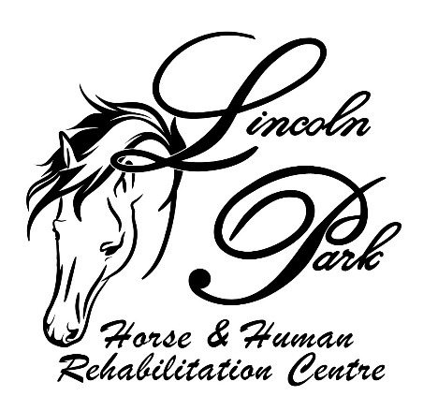

CELEBRATION OF NON RIDDEN HORSES
25th Aug 2024 10am
Monarto Sporting Complex
143 Schenscher Rd, Monarto
This show is designed to show case all those horses that cannot be ridden for whatever reason. It is designed as an encouragement for all those starting out or that just want to have some fun and show off their horse/pony. No experience necessary at showing we are here to help encourage.
Ribbons to 3rd place with numerous encouragement prizes
Ring 1 will be in hand classes and novelties, Ring 2 will be an agility obstacle course
$25 per horse enter as many classes as you like. $10 insurance fee per entry
Entry on the day or email
All proceeds go to Lincoln Park horse and Human Rehabilitation Centre.

This shows Rules and Regulations.
• All handlers need correct enclosed footwear.
• Plaiting optional. Neat casual attire.
• Lincoln Park will take no responsibility for accidents.
• The Judge’s decision is final.
• The Steward reserves the right to remove any exhibit from the ring or the grounds that is considered to be a danger to other exhibitors.
• The Committee reserves the right to cancel or alter any event on the program.
• Ages as stated in the competition will be taken as at day of Show.
• Horses must compete in the relevant height class for which they are eligible
• ENTRIES- $25 per horse enter as many classes as you like. Plus $10 insurance fee

RING 1
Starts at 10am Ribbons to 3rd Place, Encouragement prizes awarded at judge’s discretion.
- Smartest on Parade Junior (Under 18yrs of age)
- Smartest on Parade Senior (Over 18 yrs of age)
- Led Pony under 10hh
- Led Pony 10hh – 14hh
- Led Galloway 14hh – 15hh
- Led Small Hack 15hh – 16hh
- Led Large Hack 16hh and over
- Led Horse/pony foal up to 2yrs old
- Led Horse/pony 3yrs – 8yrs old
- Led Horse/pony 9yrs – 15yrs
- Led Horse/pony 16yrs – 20yrs
- Led Horse/pony 21years and over
- Handler Under 10yrs
- Handler 11yrs -15yrs
- Handler 16yrs – 18yrs
- Handler 19yrs and over
- Best Bay Horse/pony
- Best Grey Horse/pony
- Best Chestnut Horse/pony
- Best black Horse/pony
- Best Coloured Horse/pony
- Best Throughcare SA Thoroughbred
- Best Standardbred
- Best Western breed (QH, Appaloosa, Stockhorse, Palouse)
- Best Pony breed
- Best any other breed
- Best Lincoln Park Adopted horse/pony
- Horse/pony with longest tail
- Fattest Horse/pony
- Fancy Dress Junior under 18yrs
- Fancy Dress Senior over 18yrs
Novelties begin after hack classes

- Egg and spoon race junior (under 18yrs)
- Egg and spoon race senior (over 18yrs)
- Bending race Junior
- Bending race senior
- Walking race junior
- Walking race senior
- Barel Race Junior
- Barrel Senior

RING 2
Agility course to be run continuously throughout the day. You can try twice only and be judged off the higher score.
Course will consists of 10 obstacles with a score out of 10 for each. 10 being the highest.
Most points win. However there will be encouragement awards given for effort.
Looking for great partnership, boldness and training of the horse.
This is an encouragement show best to just give it a go no pressure.
Obstacles will consist of bridge, Step overs, Tarp, Alley ways etc.

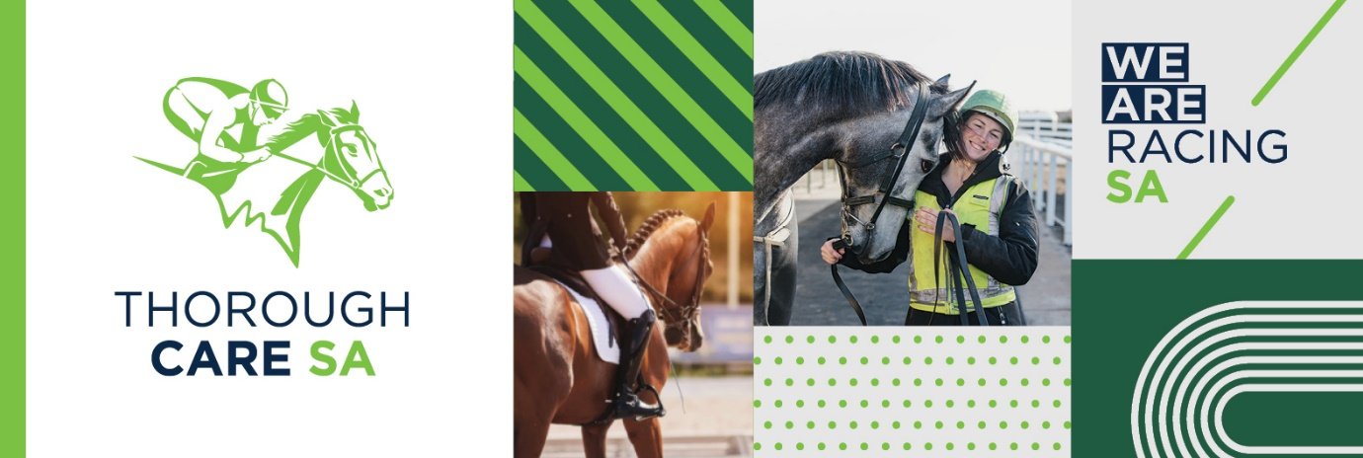

Lincoln Park Celebration of Non Ridden Horses Show
Email entries and deposit receipt to:- Lincolnparkhhcentre@gmail.com
Or enter on the day with this form.
EXHIBITOR:
ADDRESS:
SUBURB:
STATE: P/CODE:
PIC NO:
PHONE:
EMAIL:
NAME OF EXHIBIT:
CLASSES:
NAME OF EXHIBIT:
CLASSES:
Horse entry @$25.00
Insurance fee $10
Donation $
Total $

